DBMS Mini Project Synopsis

**Hospital Management System**

Name – Hrishikesh Athalye

MIS - 111803154

Class – TY Comp (Sem 5)

Div - 2

**Problem Statement**

Developing a hospital management system in order to effectively manage most aspects of hospitals such as booking appointments, managing patient records and keeping medical history and basic inventory management.

**Overview**

Organisations such as hospitals have to deal with a lot of patients regularly and hence a lot of data. Hence it is very important for a hospital to have a DBMS with a frontend that easily allows patients to book appointments and allows doctors or administrators to manage patient data.

For this project I have chosen to build the frontend using ReactJS and JavaScript, backend in Node.js and the database used will be MySQL.

**Functional Requirements**

1. Separate interfaces for patients, doctors and admin. Patients, doctors and admins should have separate logins.
2. Admins can control inventory and remove doctors.
3. Allow patients to book appointments and view/update/cancel them later if necessary, creating free slots for other patients.
4. The system should avoid clash of appointments and allow appointments only when a doctor is not already busy or does not have a break.
5. Doctors should be able access patient history and profile, and add to patient history.
6. Doctors should be able to request for inventory.

**ER Diagram**

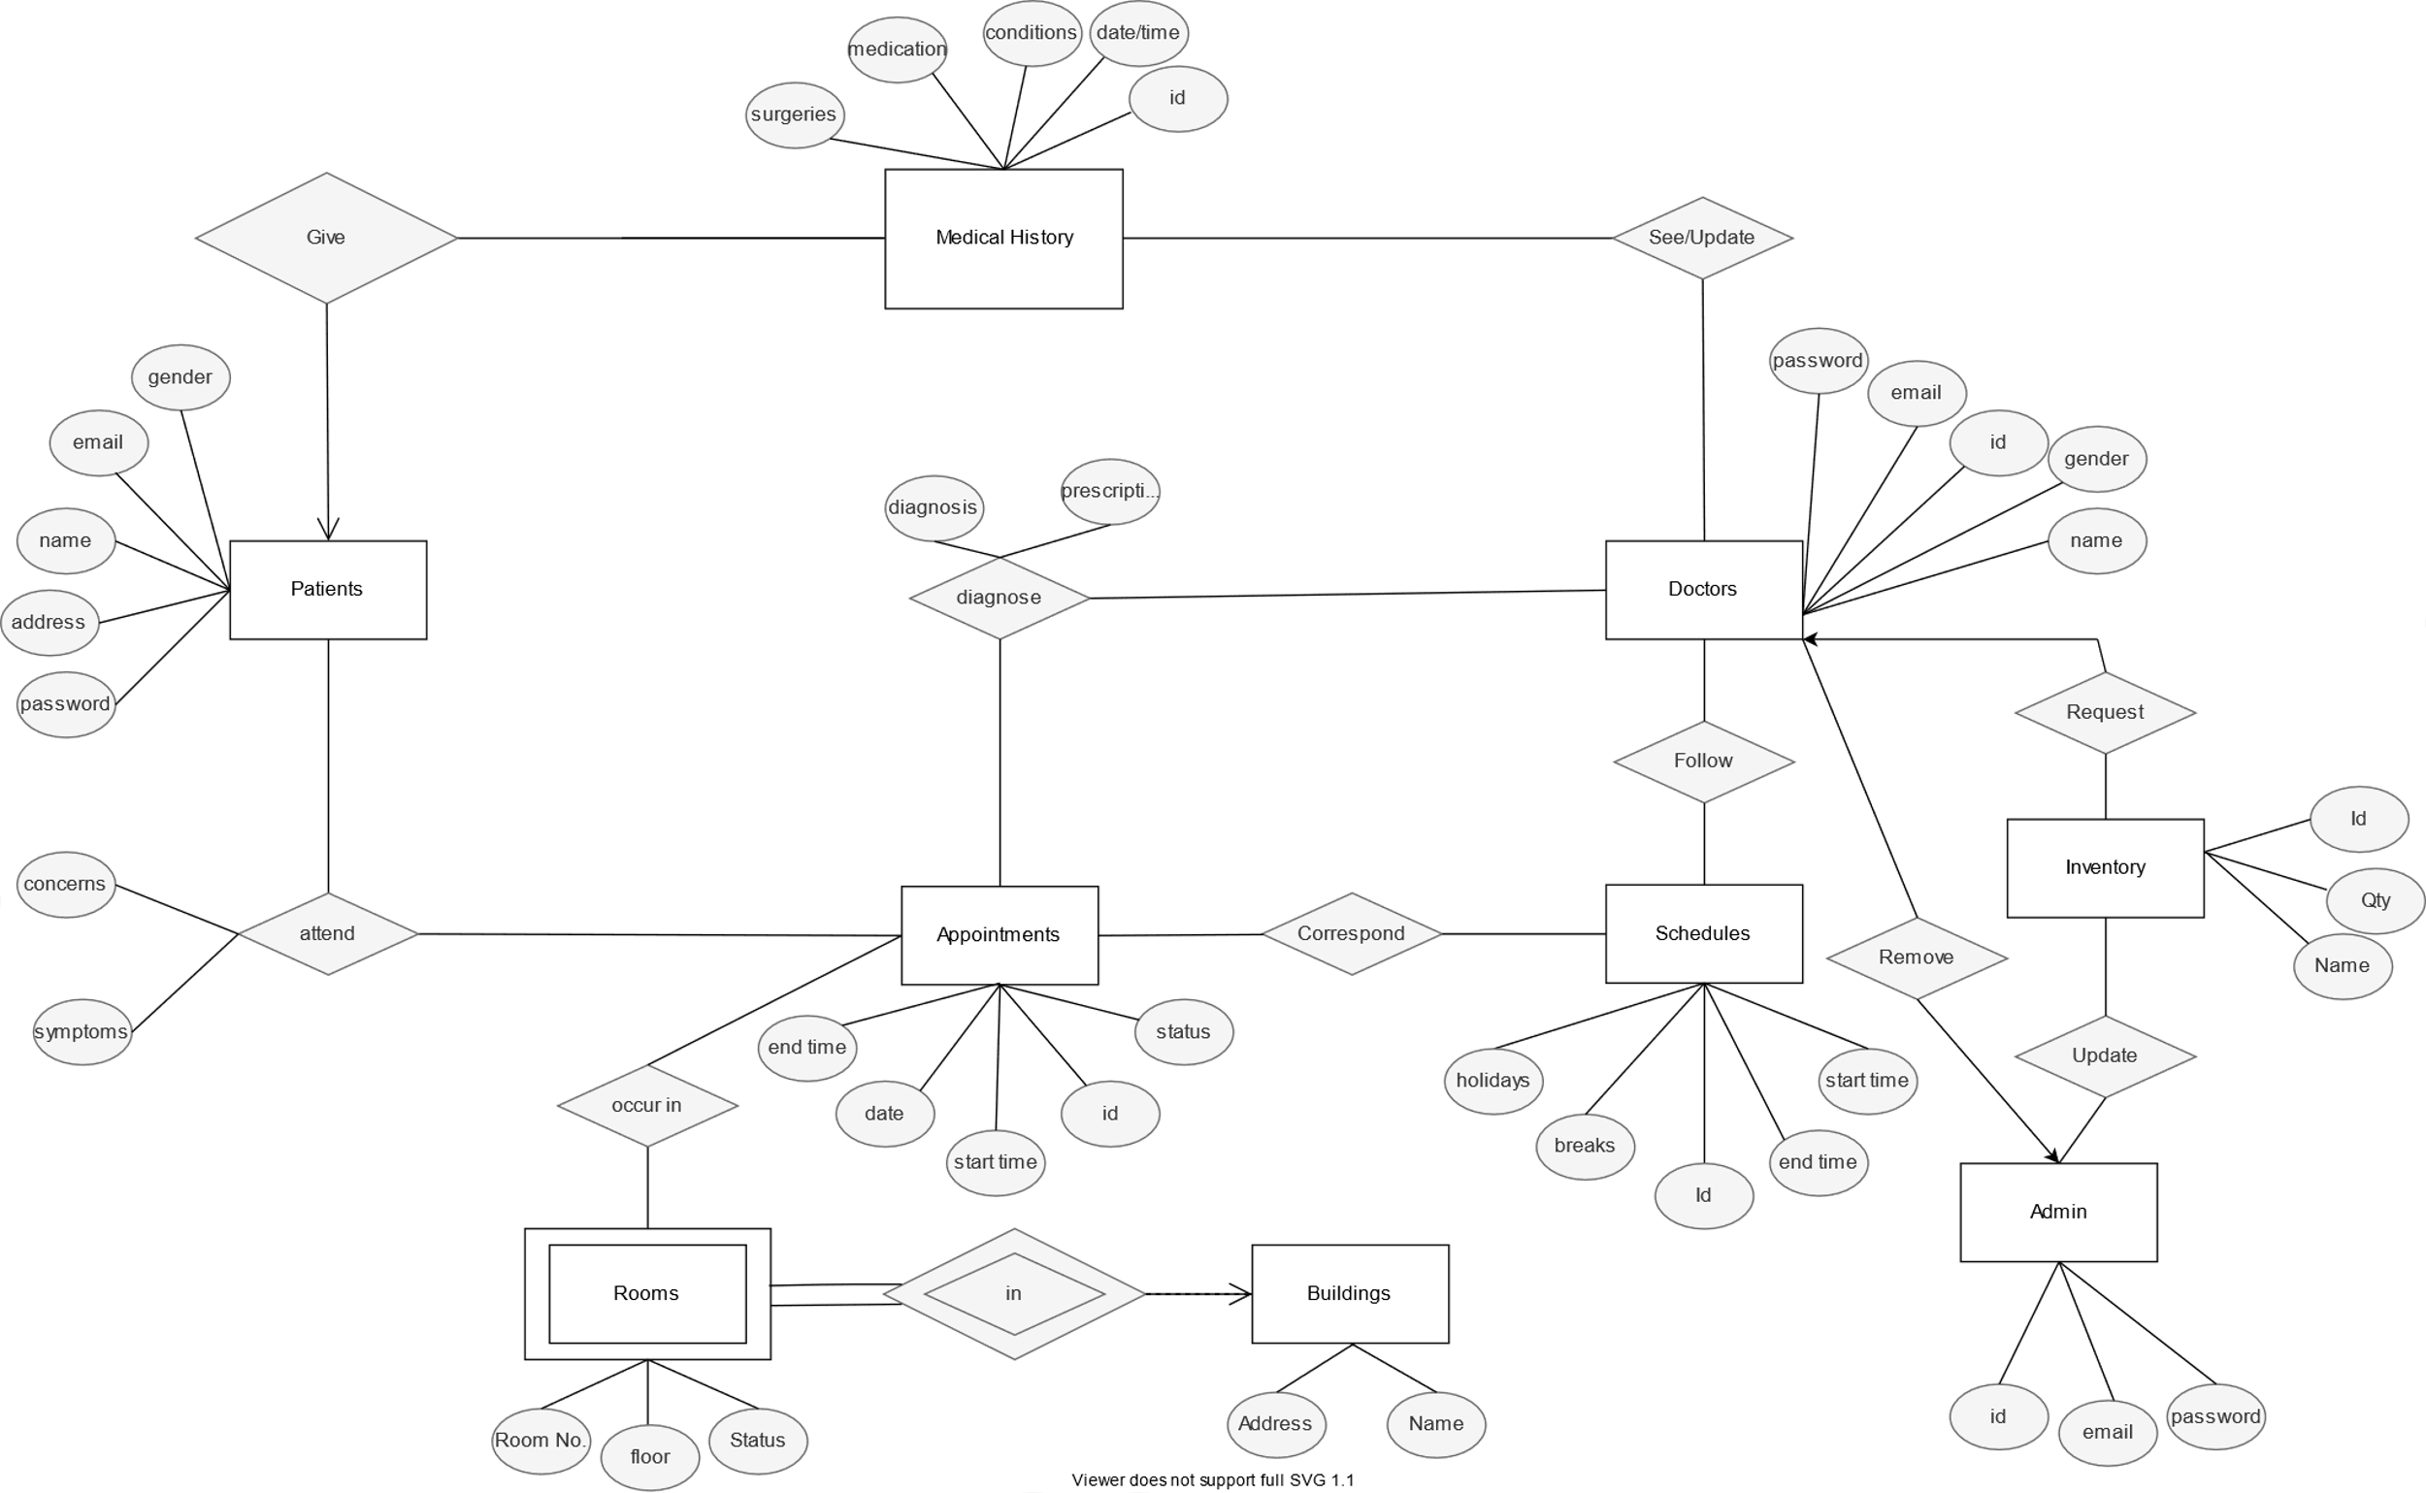

**Relational Schemas**

1. Patient

|  |  |  |  |
| --- | --- | --- | --- |
| **Email** | Password | Name | Address |

1. Doctor

|  |  |  |  |  |
| --- | --- | --- | --- | --- |
| **Email** | Gender | Password | Id | Name |

1. Medical History

|  |  |  |  |  |
| --- | --- | --- | --- | --- |
| Surgery | Medication | Condition | Date/Time | **Email** |

1. Appointment

|  |  |  |  |  |
| --- | --- | --- | --- | --- |
| **Id** | Date | Start | End | Status |

1. Schedules

|  |  |  |  |  |
| --- | --- | --- | --- | --- |
| **Id** | Start | End | Holidays | Breaks |

1. Diagnose

|  |  |  |  |
| --- | --- | --- | --- |
| **Appt Id** | Doctor | Diagnosis | Prescription |

1. Building

|  |  |
| --- | --- |
| **Name** | Address |

1. Room

|  |  |  |  |
| --- | --- | --- | --- |
| **Room_Number** | Floor | Building | Status |

1. Admin

|  |  |  |
| --- | --- | --- |
| Id | **Email** | Password |

1. Inventory

|  |  |  |
| --- | --- | --- |
| **Id** | Qty | Name |